

Jazzcash Back Office Manual Technical Document

V1

Document Control

|  |  |  |  |
| --- | --- | --- | --- |
| # | Name | Changes | By |
|  |  |  |  |
| 1 | Back Office Portal | Initial Version | Arcana Team |

# Introduction

The current employee hiring process relies on manual procedures for onboarding corporate employees, resulting in a slow and labor-intensive integration process. Additionally, any changes in employee responsibilities require documentation to be recreated from scratch. This document aims to digitize and streamline these processes to reduce or eliminate manual intervention, thereby enhancing efficiency and providing a seamless onboarding experience for our clients.

# Objective

The purpose of this document is to describe business requirement for Back Office Portal platform development.

# Components

## Login Page

**Login**

* Whenever a user enters the URL, it will be redirected to the Login page.
* After entering correct credentials, username and password, press “**Sign In**” to access the user window.
* 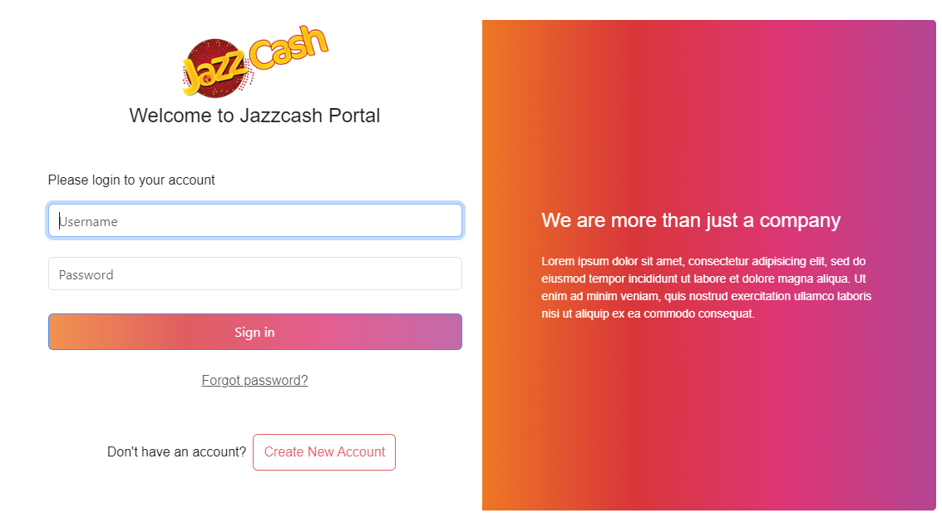User can redirect to register page to create a basic account by pressing on “**Create New Account**”.

## Register Page

**Register**

* Whenever a user enters the URL endpoint, /register, it will be redirected to the registration page.
* User has to enter the generic details, first name, last name, username (should be unique), email, phone number (11 digits), password (at least 6 characters), confirm password (must match password)
* When user presses “**Sign Up**”, the information is validated and upon successfully validating the information the user is registered and redirected to the login page.
* User can redirect to login page to log in using existing credentials by pressing on “**Login**” button on the screen.

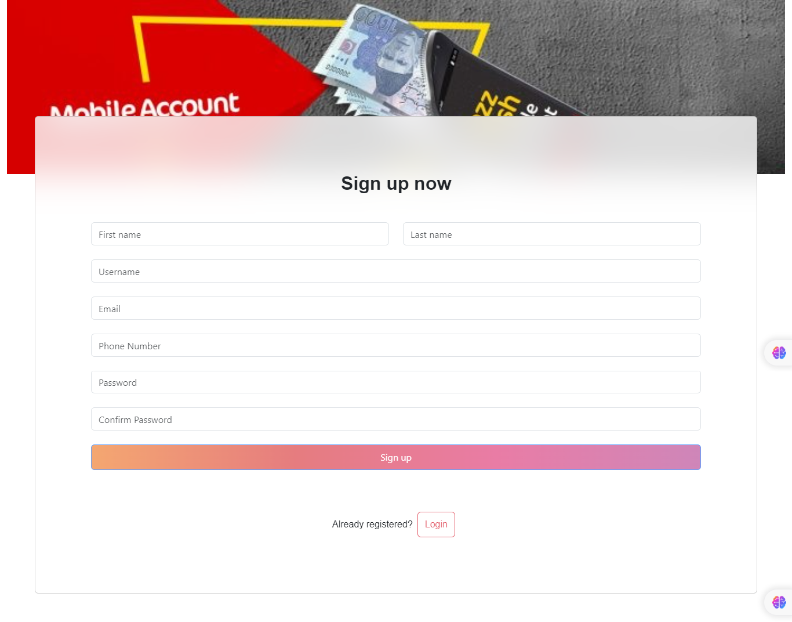

## OTP Verification Page

**Send OTPs**

* When user successfully enters correct credentials, they are redirected to OTP Verification page.
* The user can confirm the details of the email and phone number that they have provided during registration. After that they may proceed to “**Send OTPs**” to request OTPs on respective email and phone number for two factor validation.

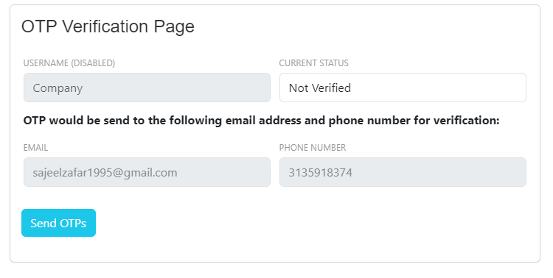

**Submit OTPs**

* User has to provide the OTPs sent to the mobile number and email. The expiration time of OTPs has currently been sent to 5 minutes after which user will have to request new OTPs from the server.
* If user has entered correct OTPs successfully within 5 minutes and pressed the “**Submit OTPs**” button. He will be redirected to his own window (depending on permissions he has been assigned)

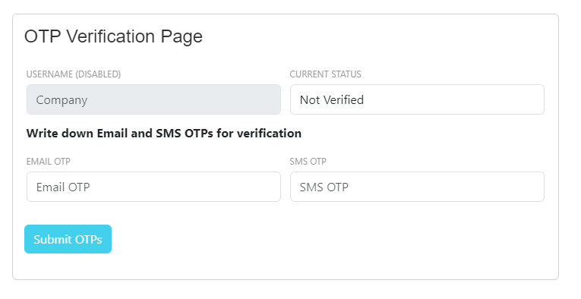

In case user enters incorrect OTPs, they are notified using a toast message. In case of OTP expiration, the user would be redirected to the send OTPs page in order for him to resend OTPs for validation.

## Dashboard Page

After successfully validating the OTPs, the user will be redirected to their dashboard page. The window of each user will be referred to as “**Dashboard**”. Each user will have his own window, depending on the permissions assigned to them. Attached is the screenshot of the **SuperAdmin** dashboard that has all the possible permissions for in-depth explanation of each tab. There can only be one SuperAdmin, the permission “**Role Assignment**” would only be visible to SuperAdmin.

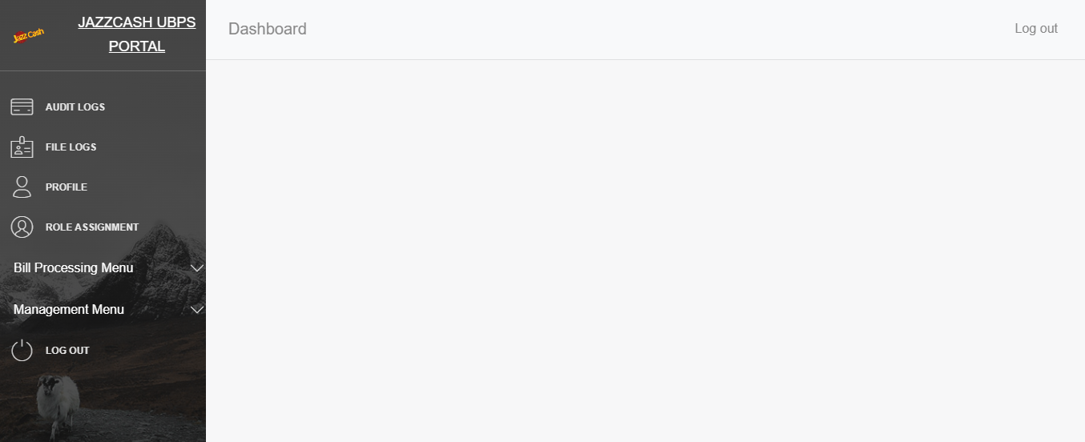

**Audit Logs**

* Upon selecting “**AUDIT LOGS**” from the sidebar, the user manages to view all the recent operations performed on the back-office portal by all users.
* The logs are arranged in descending order for ease of finding.
* The system features an advanced search bar that enables users to filter logs based on specific criteria. Users can select a column from the dropdown menu to apply a search filter, by clicking on “**Search**” button, and enter a keyword on the right to match content in that column. By default, the search will encompass all columns for the entered keyword in the input box.

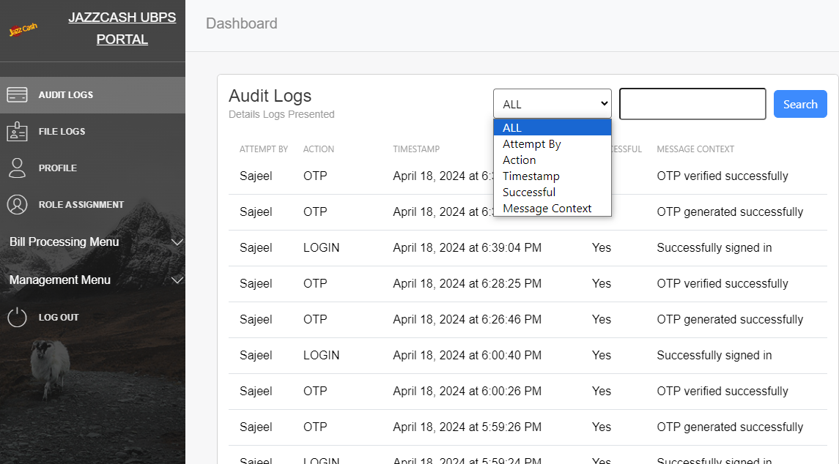

**File Logs**

* Upon selecting “**FILE LOGS**” from the sidebar, the user manages to view all the recent files uploaded on the back-office portal by all users.
* The system features an advanced search bar that enables users to filter logs based on specific criteria. Users can select a column from the dropdown menu to apply a search filter, by clicking on “**Search**” button, and enter a keyword on the right to match content in that column. By default, the search will encompass all columns for the entered keyword in the input box.
* The user can also view the file details by pressing the “**Open Folder**” button. He would be redirected to the path where the file is stored initially

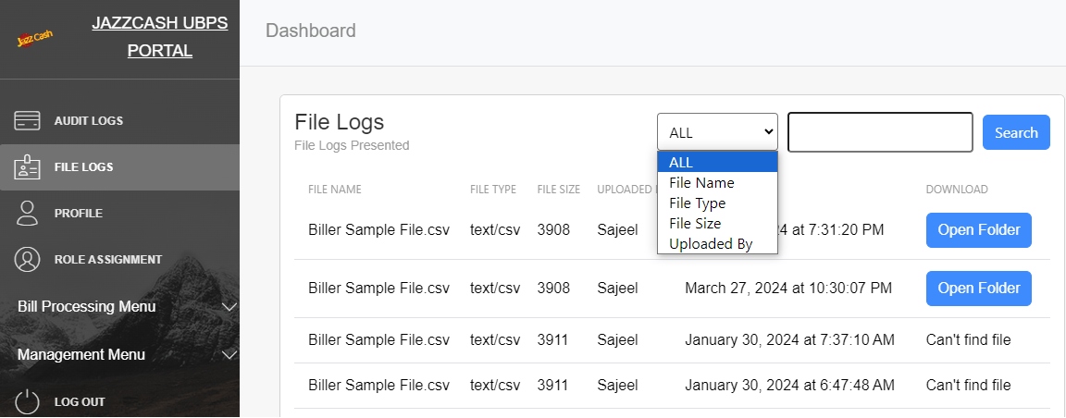

**Profile**

* By clicking on “**PROFILE**” on the side bar user will be displayed their details that they submitted during account creation.

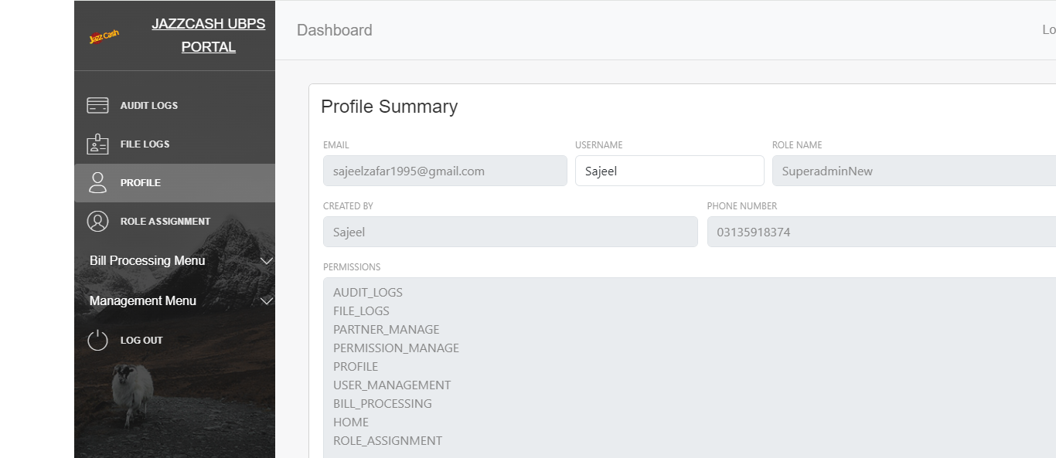

**Role Assignment (Super Admin Access Only)**

* By clicking on “**ROLE ASSIGNMENT**” on the side bar Super Admin will be asked to enter the username for whom they want to create / assign role to.
* Super Admin can create new roles as well as assign roles to existing users using this window.

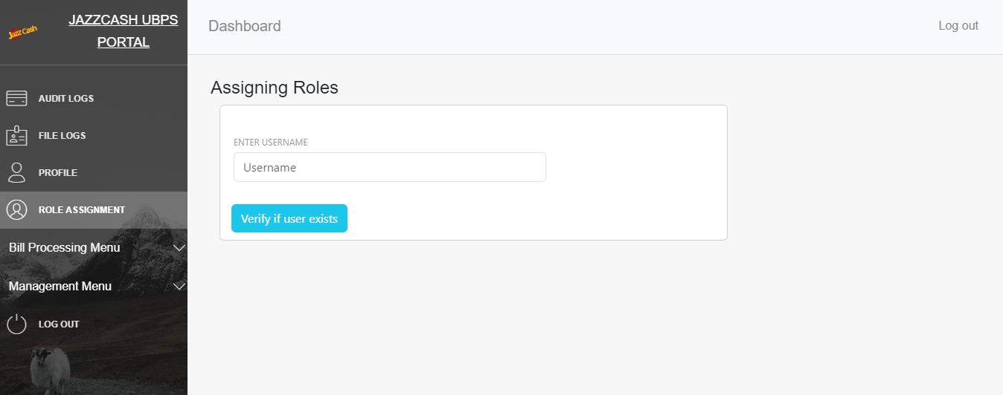

If correct username is provided it would redirect to roles assigning page. If the user does not exists it would through a toast message displaying “User not found”.

* If user is found the following screen is visible. Super Admin can assign user from existing roles, create a new role only and create a new role and assign the current user.
* Below Super Admin has selected radio button, “**EXISTING ROLE**” so they have to select from the existing roles and can’t create a new one in this window.
* Super Admin can view the permissions a particular role is assigned by clicking on “**View Permissions**” button.
* Super Admin can select any one radio buttons under heading “**Existing Rolenames**” and click on the button “**Assign the role to ${username}**” to assign the role to that user, in this case **Faizan**.
* If Super Admin changes his mind and wants to change role for any other user, they can select “**Search another User**” button which would redirect them to the previous window.

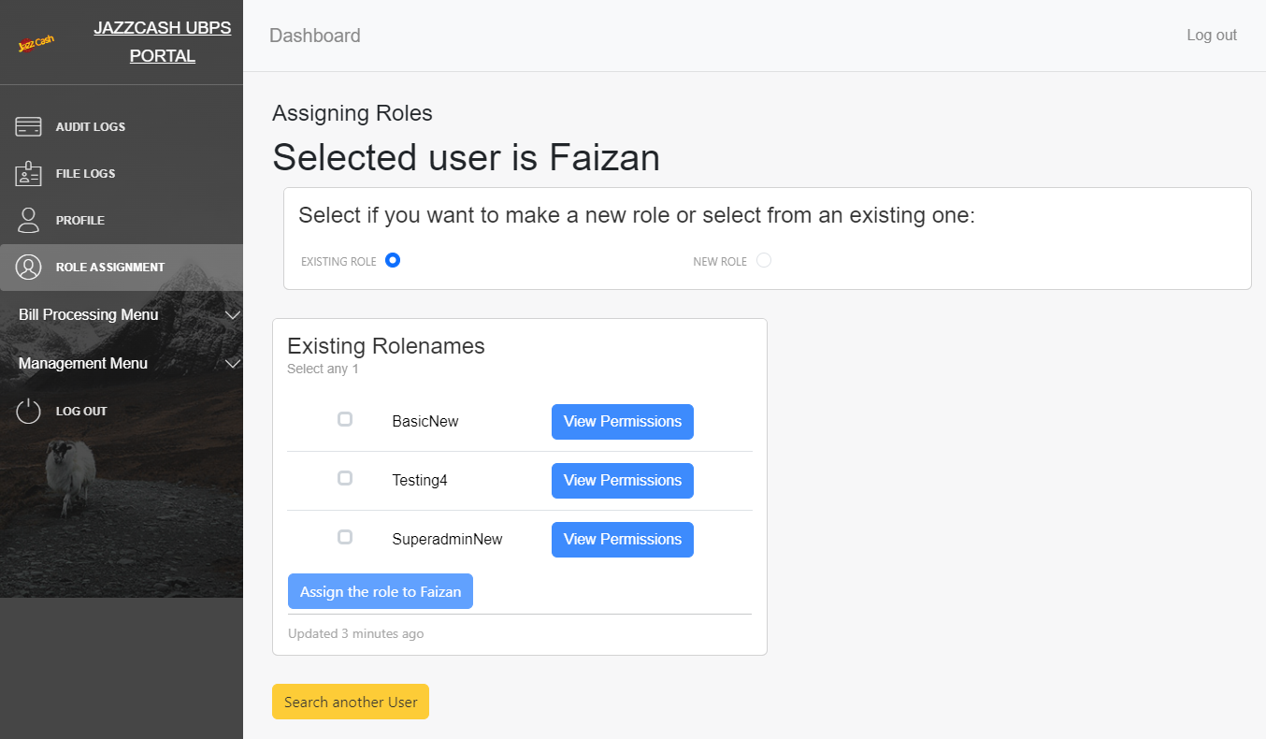

* Below Super Admin has selected radio button, “**NEW ROLE**” so they have to create a new user and can’t select from the existing roles in this window.
* If Super Admin cannot find a role with suitable permissions, they can create a custom role with their own set of permissions.
* The rolename inside the label “**ROLENAME**” shall be unique. If not the error will be displayed “**Role name is already taken**”.
* After naming the role, Super Admin can mark the respective permissions they desire for the role with the help of checkboxes.
* They can also choose using radio buttons whether they want to create the role only or create and assign to the selected user, in this case Faizan.
* Finally they can press “Create Role Only” or “Create Role and Assign {user}” button as per the radio button selected.
* Screen shot of both cases are attached.

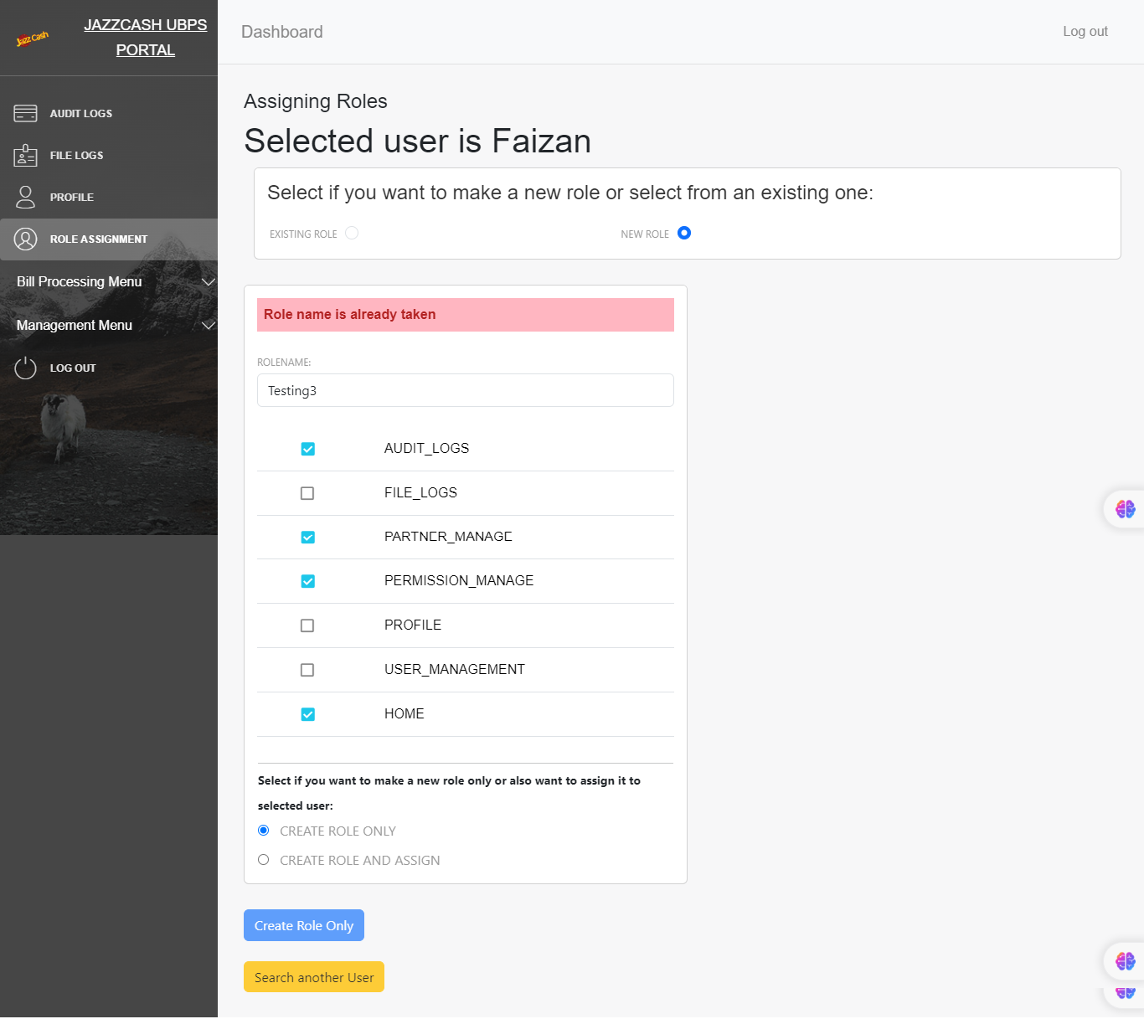

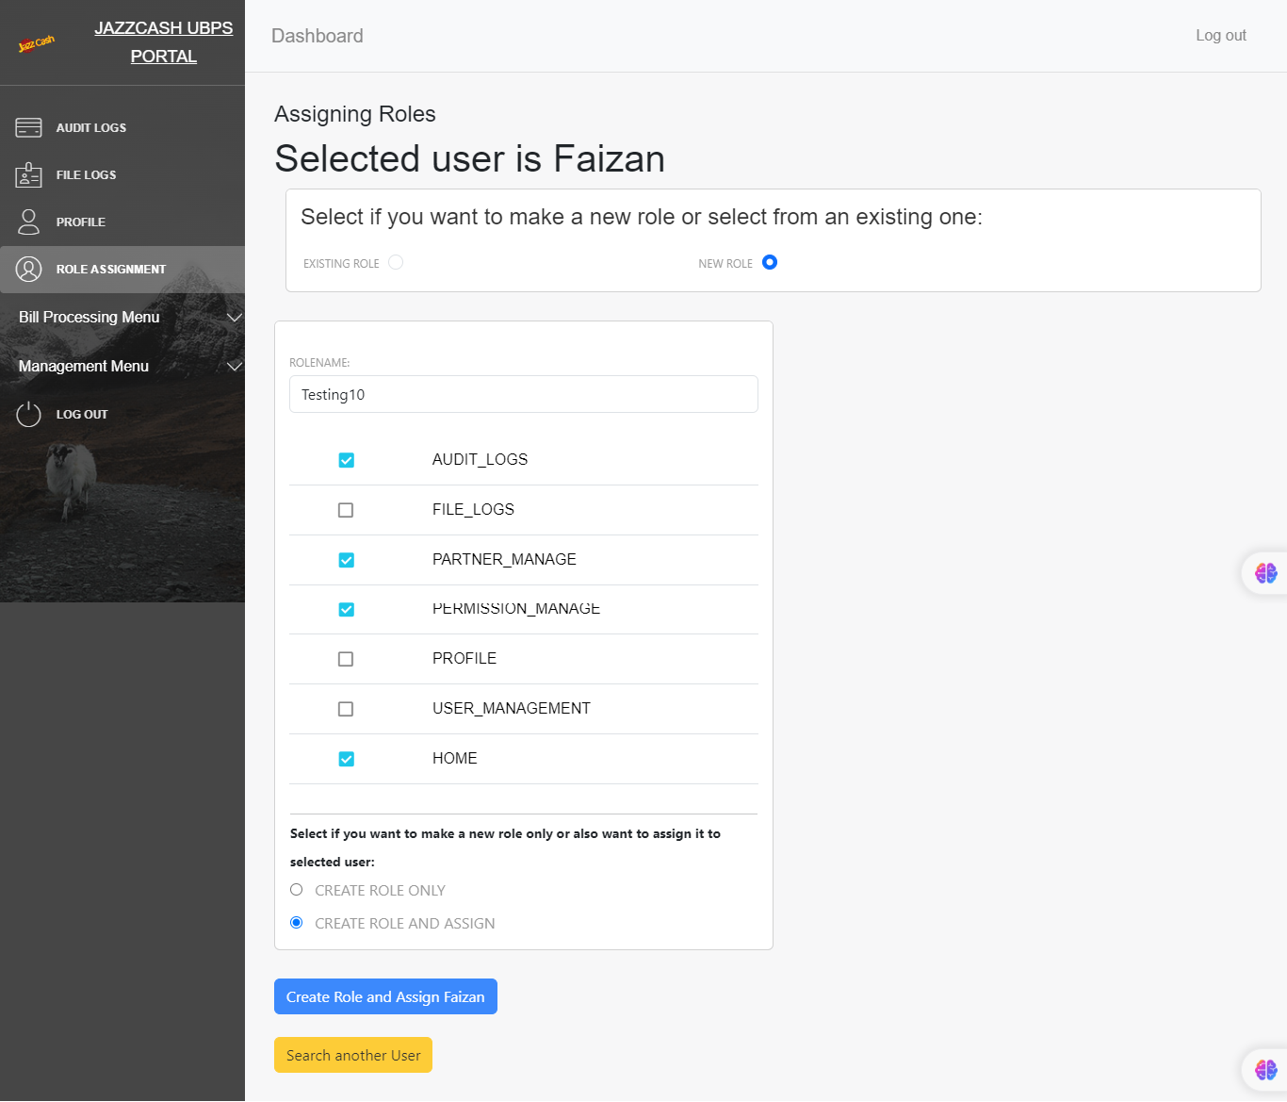

**Bill Processing Menu**

* By clicking dropdown “**Bill Processing Menu**” on the side bar followed by “**FILE UPLOAD (CSV)**” user will be displayed the following window.

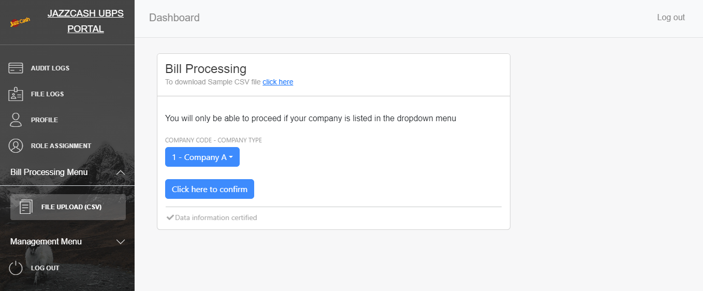

* By clicking the "click here" link, users can download a sample CSV file that matches the format expected for uploading. This allows users to verify if their file matches the expected format and helps them troubleshoot any "failed to upload" errors they encounter.
* The user will be shown the list of all offline companies to choose from on clicking the drop-down button as shown below.
* The user shall select their company and click on “**Click here to confirm**” to proceed to the file upload.

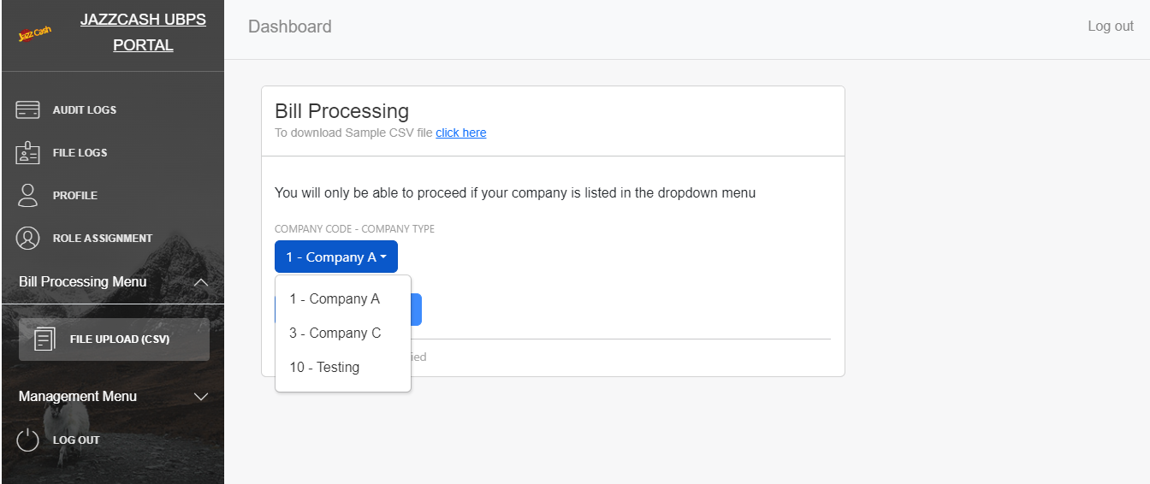

* Now the user has to choose file from his computer memory and upload the file to the system.
* If the file is uploaded successfully the user would get the message “**✅ File uploaded successfully!**”.
* If some of the records were not updated successfully or are duplicated, the following msg would be generated “**{no of success Responses} were uploaded, ${no of failed Responses} had format issue in them. Duplicate responses were ${no of duplicate Responses}**”

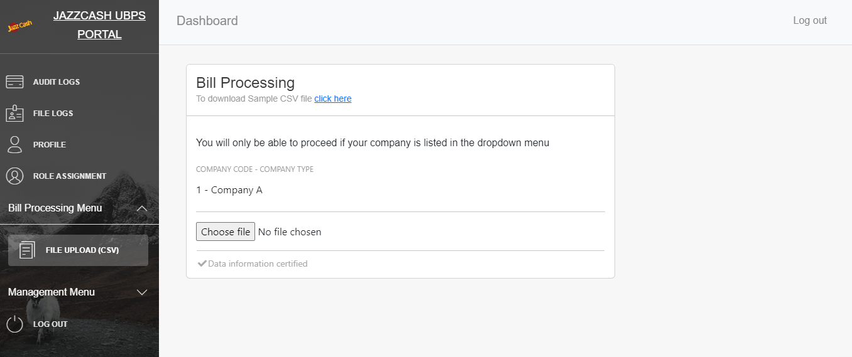

**Partner Manage**

* By clicking dropdown “**Management Menu**” on the side bar followed by “**PARTNER MANAGE**” user will be displayed the following window.
* Upon selecting “**PARTNER MANAGE**” from the sidebar, the user manages to view all the partners registered on the back-office portal.
* The system features an advanced search bar that enables users to filter logs based on specific criteria. Users can select a column from the dropdown menu to apply a search filter, by clicking on “**Search**” button, and enter a keyword on the right to match content in that column. By default, the search will encompass all columns for the entered keyword in the input box.

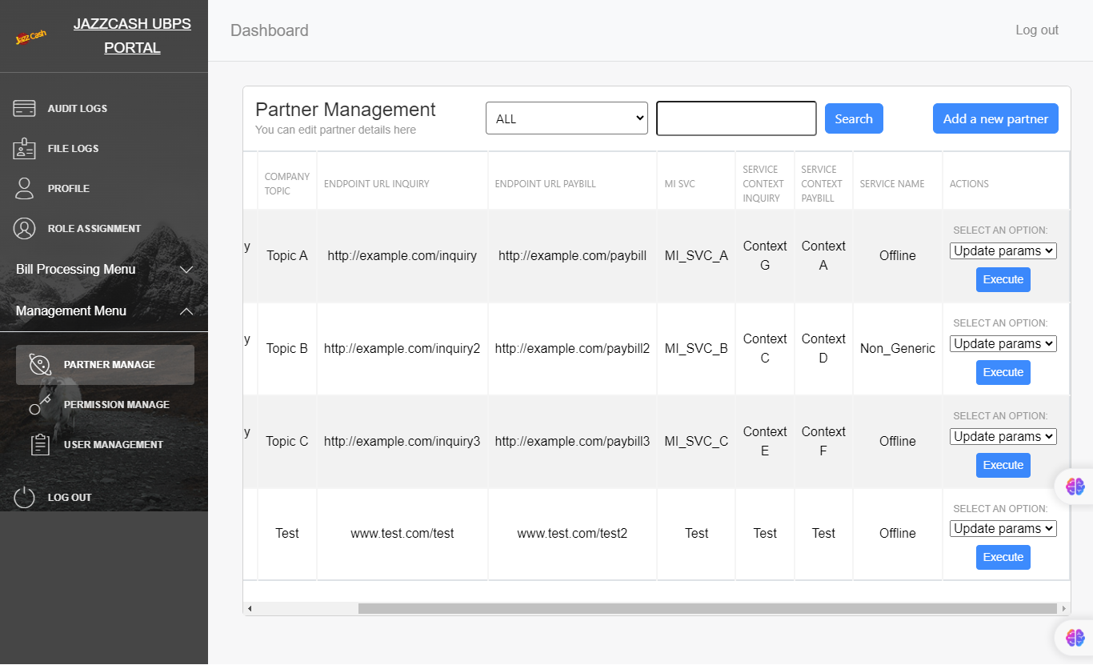

* The following actions can be performed to the existing partner data, “**Update Params**” and “**Delete Partner**”.

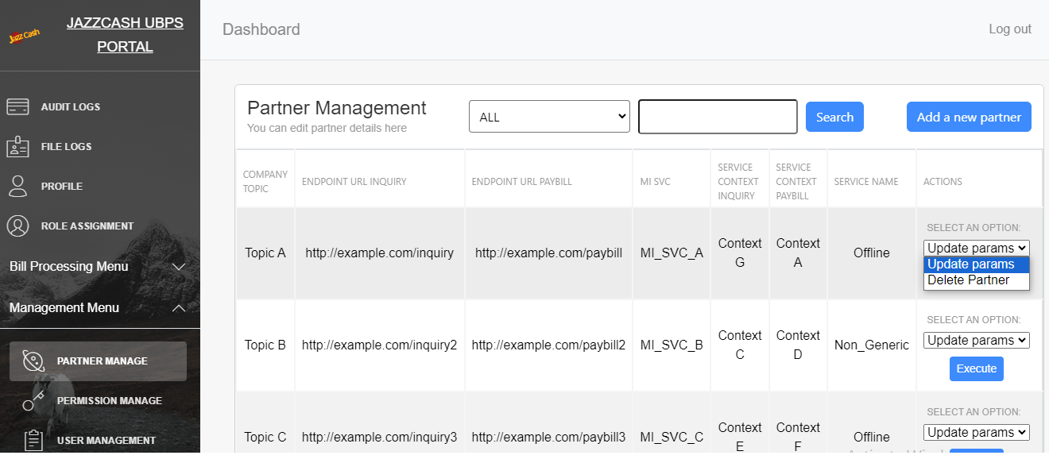

* “**Update Params**” would make that row editable and user can edit the partner information then.
* After editing the partner information user can press “**Save Changes**” button to save the changes done to the partner information or the “**Cancel Changes**” button to revert to the previous saved data.

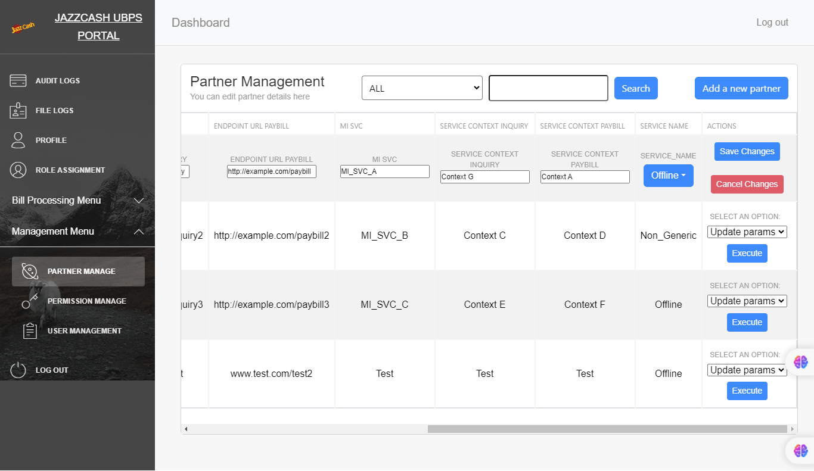

* “**Delete Partner**” would pop up a dialog box asking for confirmation to delete that particular partner.
* If selected “**Yes**” the partner would be deleted. If selected “**No**” or “**Close**”, the partner would be retained.
* In either case the popup would be closed.

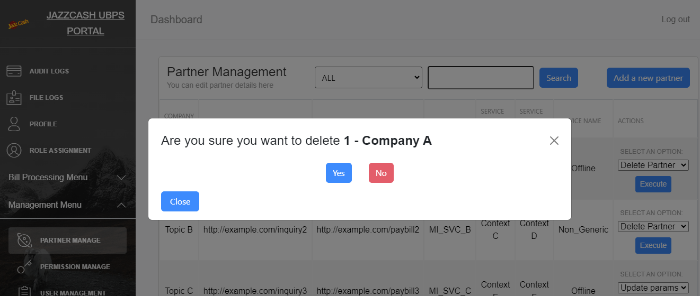

* By clicking on “**Add** **a new partner**” button the following form, on the next page, would be displayed.
* To add a new partner, fill out all the fields and press “**Submit**” button to register a new partner.
* The partner will be added after successful validation.

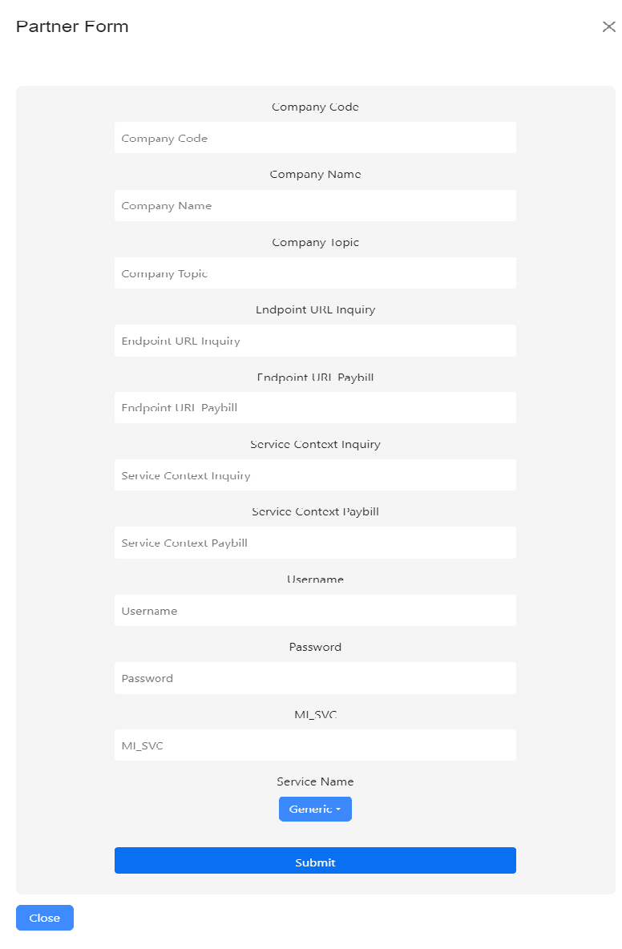

**User Management**

* By clicking dropdown “**Management Menu**” on the side bar followed by “**USER MANAGEMENT**” user will be displayed the following window.
* Upon selecting “**USER MANAGEMENT**” from the sidebar, the user manages to view all the users registered on the back-office portal.
* The following actions can be performed to the existing partner data, “**Edit Name**”, “**View User**” and “**Delete User**”.

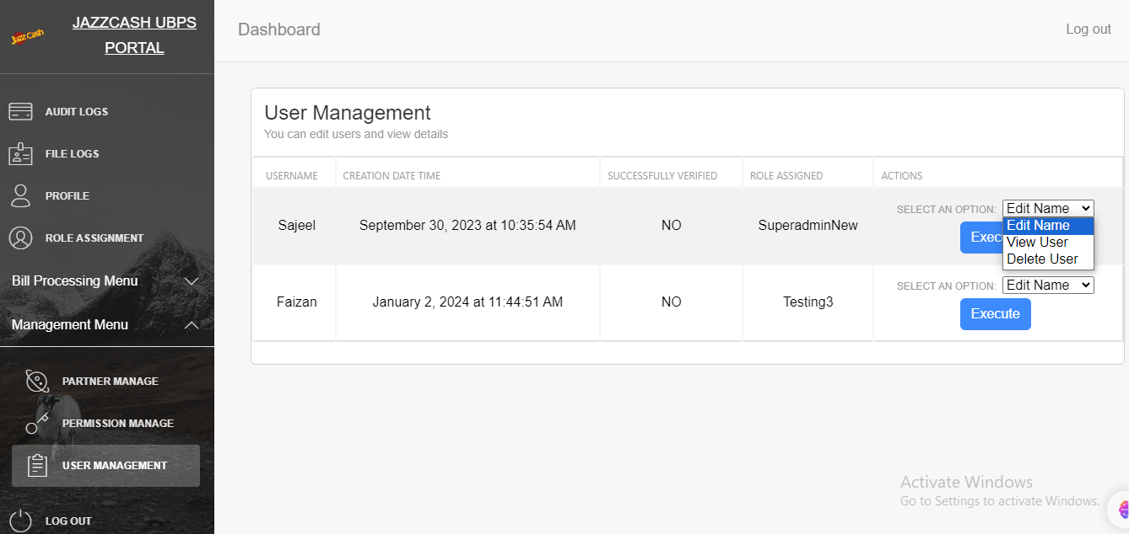

* “**Edit Name**” would pop up a dialog box asking for confirmation to change name for that particular user.

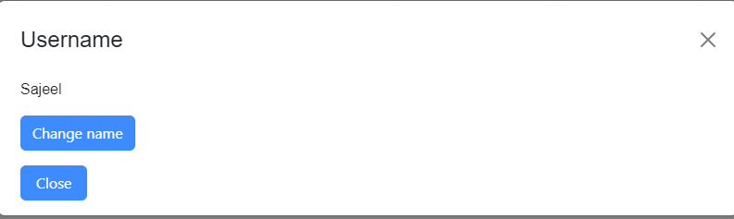

* If selected “**Change name**” the user would be tasked to assign a new name.
* If a valid username is entered and selected “**Confirm Name**” the user name would be updated with a toast message “**Username Successfully Changed**”. If username is not valid (occupied by any other) the name would not be updated and a toast message would be displayed “**Username Already Exists**”.

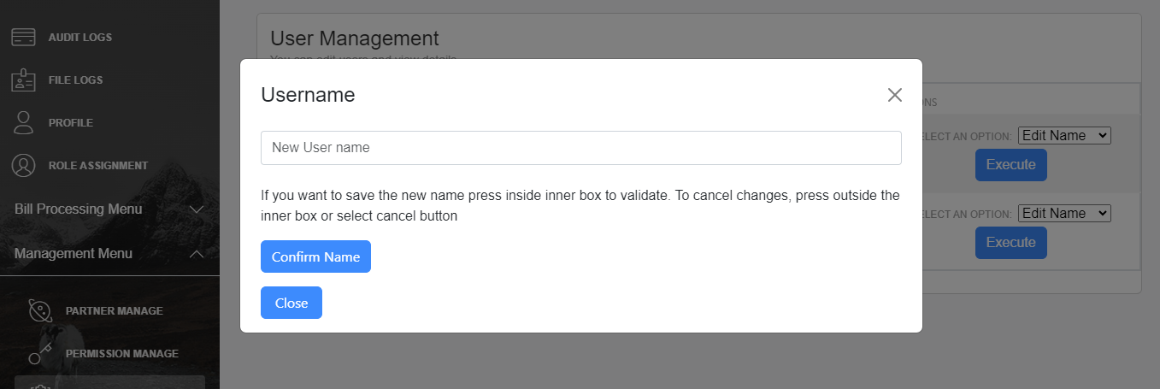

* “**View User**” would redirect to the profile page with the selected user details and preview the details of the selected user.

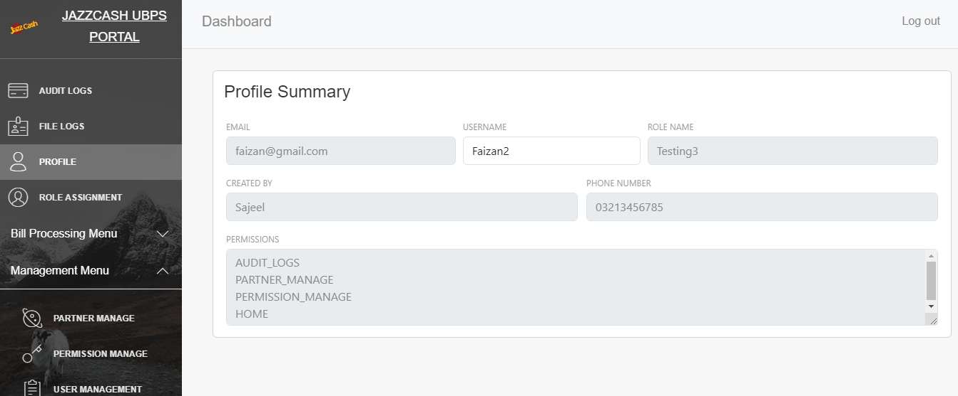

* “**Delete User**” would pop up a dialog box asking for confirmation to delete that particular user.
* If selected “**Yes**” the user would be deleted. If selected “**No**” or “**Close**”, the user would be retained.
* In either case the popup would be closed.

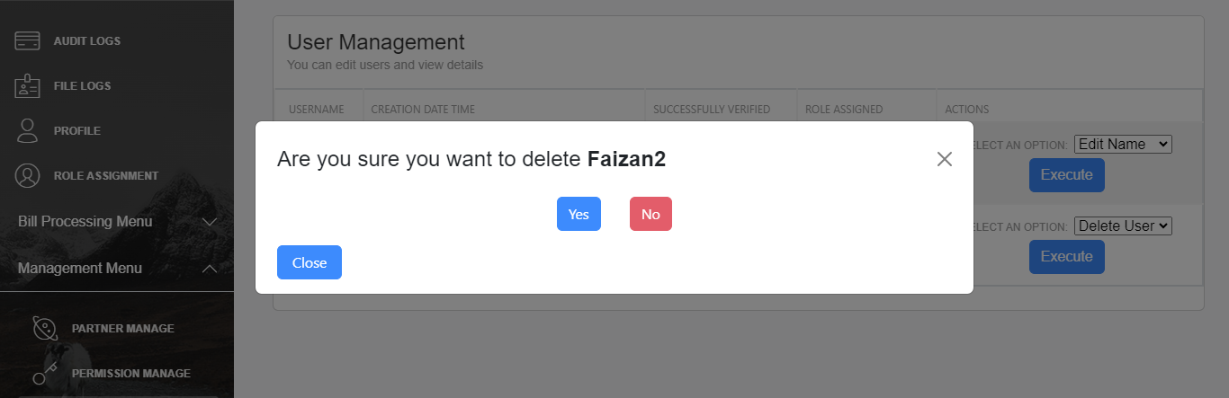

**Permission Management**

* By clicking dropdown “**Management Menu**” on the side bar followed by “**PERMISSION MANAGEMENT**” user will be displayed the following window.
* Upon selecting “**PERMISSION MANAGEMENT**” from the sidebar, the user manages to view all the permissions registered on the back-office portal.

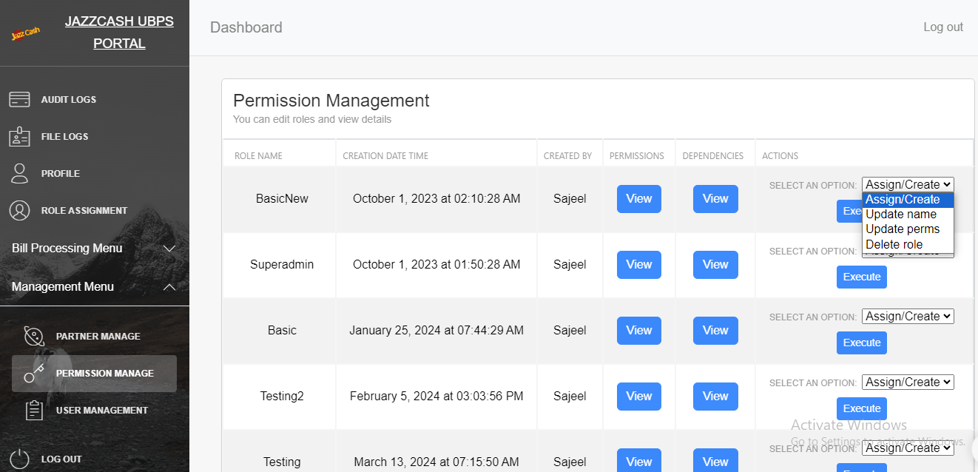

* The “**View**” button under “**PERMISSIONS**” column illustrates the respective permission that particular role has.

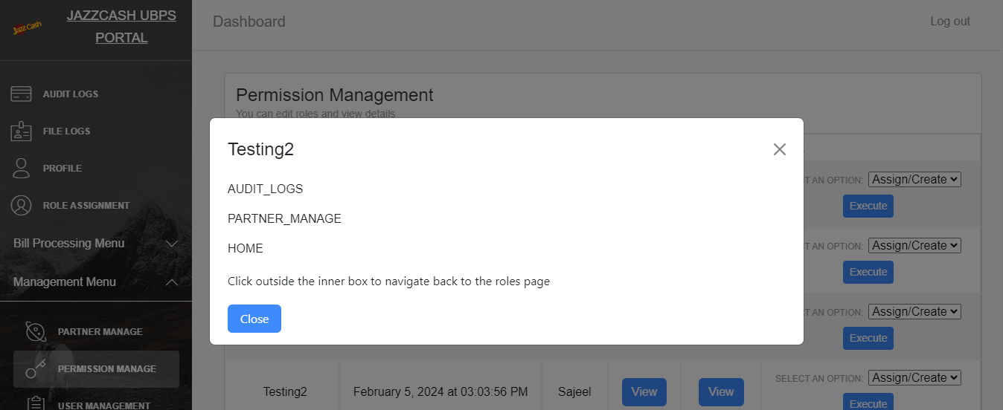

* The “**View**” button under “**DEPENDENCIES**” column illustrates the respective user associated to that particular role. If the role is assigned to any user, means it has dependencies, the role cannot be deleted.

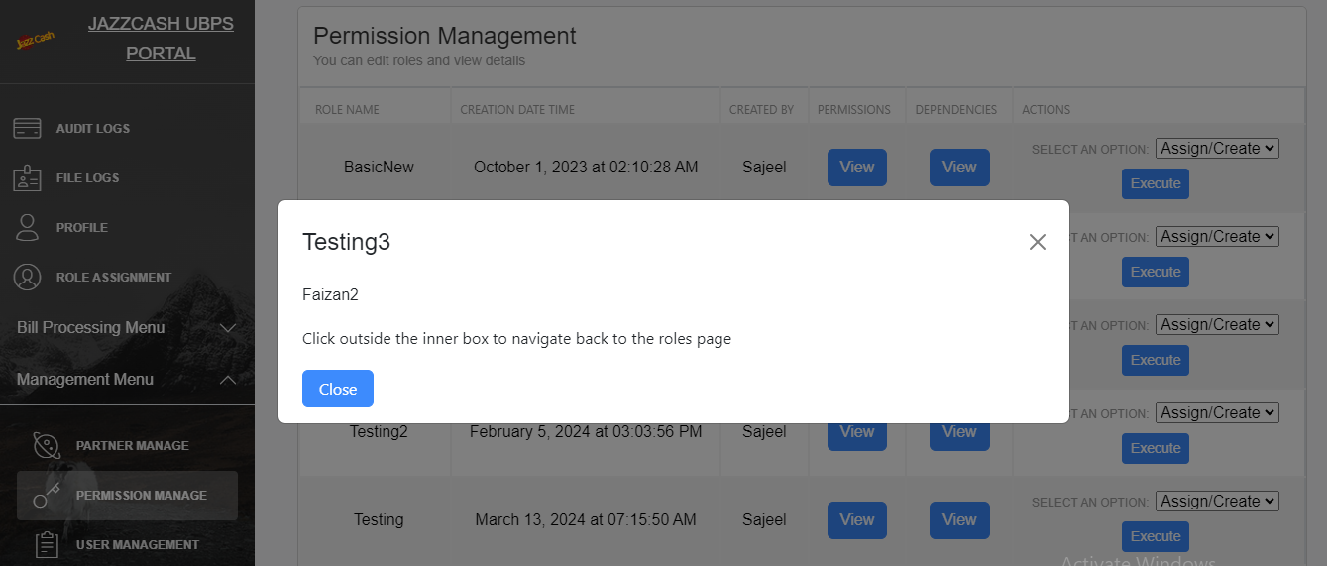

* The following actions can be performed to the existing partner data, “**Assign/Create**”, “**Update name**”, “**Update perms**” and “**Delete role**”.
* If “**Assign/Create**” action is selected and “**Execute**” button is pressed the user will be redirected to “**ROLE ASSIGNMENT**” tab if user has respective permission. Navigate to the previous headings to find how it operates.
* If the user does not have respective permission a page would be reloaded stating that they are not authorized to this page.
* “**Update Name**” would pop up a dialog box asking for confirmation to change name for that particular role.

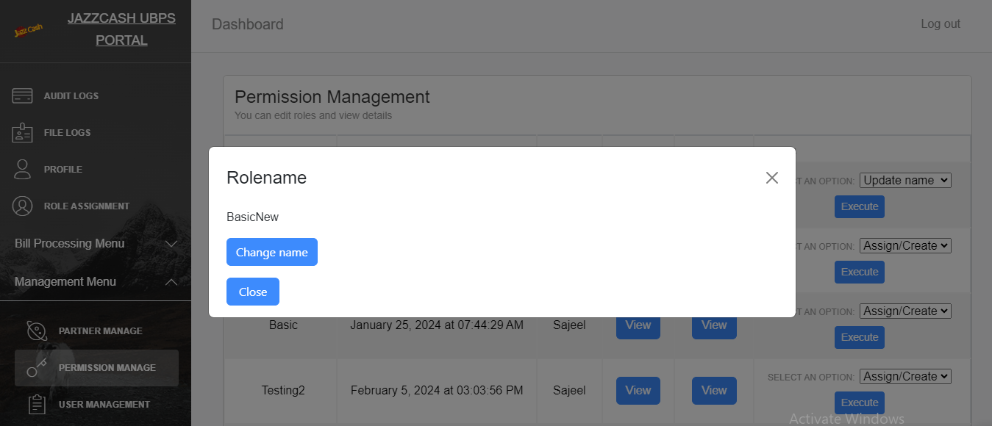

* If selected “**Change name**” the user would be tasked to assign a new name.
* If a valid role name is entered and selected “**Confirm Name**” the role name would be updated with a toast message “**Rolename Successfully Changed**”. If role name is not valid (already exists) the name would not be updated and a toast message would be displayed “**Rolename Already Exists**”.

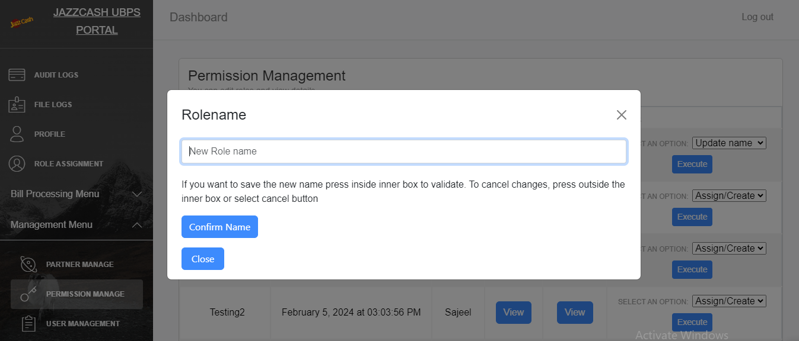

* “**Delete role**” would pop up a dialog box asking for confirmation to delete that particular role.
* If selected “**Yes**” the role would be deleted, given no dependencies. If selected “**No**” or “**Close**”, the role would be retained.
* In either case the popup would be closed.
* If role is not deleted due to dependencies, the toast message would be displayed, “**Role has dependencies**”.
* If the role is successfully deleted, the toast message would be displayed, “**Role successfully deleted**”.



* By clicking on “**Update perms**” the following pop up would appear. User can add or remove permissions using “**-**” button to remove existing permission from the selected role name or “**+**” button to add permission to selected role name.
* On selecting “**Confirm permissions**” button the permissions would be updated for the selected rolename.

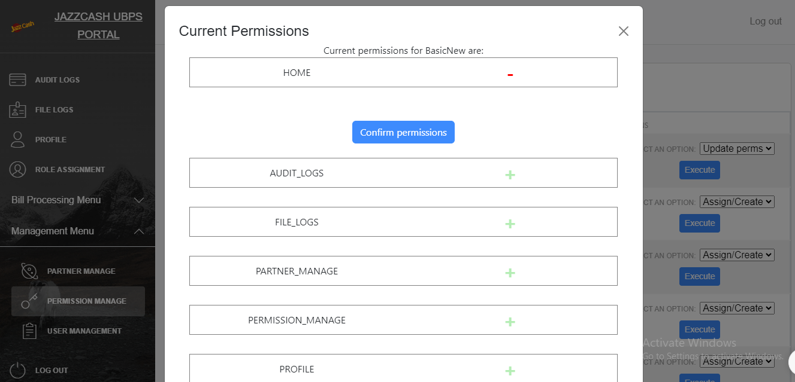

**Logout**

* By clicking on “**LOG OUT**” on the side bar user will be logged out from the session and redirected to the Log In page.